Tobin Haefele

uNIVERSITY OF mONTANA

Russian Olive Report

rEPORT ON THE CURRENT AND FUTURE STATUS OF RUSSIAN OLIVE IN MISSOULA COUNTY

Table of Contents

1. Introduction 2

2. Background 2

3. Methodology 4

3.1 Model and Variable Selection 4

3.2 Data Sources 6

3.3 Data Cleaning and Integration 6

3.4 Model Preparation 7

4. Analysis 9

4.1 Initial Analysis 9

4.2 Random Forest Results 12

5. Recommendations 15

6. Conclusion 16

7. Appendices 18

8. References 19

# Introduction

The Russian Olive project originated from my interest in native plants and their ecological importance in Missoula and the surrounding Montana area. This interest was sparked by personal experiences, such as planting native species in my yard, and grew into a desire to contribute to local conservation efforts. While I initially sought a project directly related to native plants, I realized that supporting native ecosystems also involves addressing the spread of invasive species. This led me to focus on invasive species management, specifically the Russian Olive, which was recently listed as a new invasive species in Missoula County in 2024.

To narrow the scope of the project, I chose to concentrate on Missoula County, as statewide efforts, such as those led by the Montana Natural Heritage Program (MTNHP) and Bryce Maxwell, have already made significant progress in this area. After reaching out to the Missoula County Ecology Extension, I learned about their ongoing field surveys and concerns regarding the Russian Olive. They provided valuable data and context, which became the foundation for this project. This report aims to support their efforts by identifying areas most susceptible to Russian Olive invasion and providing actionable insights for mitigation and removal strategies.

This report is intended for the staff of the Missoula County Ecology Extension, the Missoula County Weed Board, and other interested parties, including the public. Its goal is to inform decision-making around resource allocation and mitigation efforts, ensuring that limited resources are used efficiently to combat the spread of Russian Olive.

The primary question this project addresses is: Which areas in Missoula County are most susceptible to invasion by Russian Olive? By answering this question, the report provides critical information about the current distribution of Russian Olive and identifies potential areas for future management efforts.

# Background

Russian Olive (*Elaeagnus angustifolia*) is a small tree native to southern Europe and western Asia. Introduced to North America during colonial times, it was initially planted for practical purposes, such as windbreaks, and for its ornamental appeal. However, it has since escaped cultivation and is now considered an invasive species, particularly in riparian zones—areas along riverbanks where it thrives and spreads rapidly. In Montana, Russian Olive was first planted as a windbreak as early as 1953, but its unchecked spread has led to significant ecological concerns. As of 2010, the Russian Olive is listed as State Regulated by the Montana Department of Agriculture, which means it is illegal to intentionally spread or sell.

One of the main issues stemming from this is the overcrowding and eventual overtaking of native species within the ecosystem. Native species such as the cottonwood and willow occur in the same environment as the Russian Olive, causing competition between the species. This is an issue due to certain characteristics that give Russian Olive an advantage in this competition. Unlike the native Cottonwood the Russian Olive can reproduce in the shade[1], as the Cottonwood’s die off the Russian Olive lives on. Since the cottonwood can’t reproduce in the shade, the Russian Olive begins to take over as the dominant species.

Another advantage is the aversion of Beavers to Russian Olive, researchers found that Beavers tended to damage 57 to 78 percent of cottonwood trees, while only damaging a mere 15 to 18 percent of Russian Olive Trees[2]. Furthermore, the damage to Russian Olive tended to be primarily the limbs, while damage to the Cottonwood tended to be at the trunk or base of the tree.

Additionally, Russian Olive thrives in areas with regulated river flows, such as those impacted by dams or irrigation systems. These human-altered environments create ideal conditions for their growth, allowing them to spread more aggressively. As a result, Russian Olive not only disrupts natural ecosystems but also exacerbates the challenges of managing riparian areas in the face of human activity.

The loss of native species like the Cottonwood also means the loss of habitat for native animal species, for example cavity-nesting birds that rely on the Cottonwood to reproduce, do not appear to use Russian Olive as a replacement. Ungulates such as the White-Tailed Deer prefer to forage near cottonwood trees at a much higher proportion when compared to the Russian Olive. Preserving these fragile ecosystems is an important step in combatting climate change at the local level.

Several studies have examined the distribution of Russian Olive in Montana, including a notable study by Lesica and Miles, which tracked its spread along the Marias and lower Yellowstone rivers in eastern Montana. More recently, researchers used NAIP imagery and a random forest model to create a land cover map of valley bottoms for ten eastern Montana rivers, with Russian Olive included as one of the mapped land cover types. These studies have provided valuable insights into the species’ behavior and impact in Eastern Montana.

However, fewer studies have focused on the western part of the state, particularly in Missoula County. According to data from the Montana Natural Heritage Program (MTNHP), observations of Russian Olive in Missoula County have increased in recent years, as shown in Figure 1 below. This uptick in observations underscores the need for localized research to understand the current distribution of Russian Olive and predict areas where it may spread in the future.

One caveat to this statement is the small amount of data in the MTNHP database for Missoula County (around 53 entries). The other issue is the lack of data prior to 2023 from Missoula County. There are some observations starting in 2012, but most of them come from the 2023 field survey.

Given that Russian Olive was recently added to Missoula County’s watch list of invasive species, this project seeks to fill critical gaps in knowledge about its spread in the region. By identifying areas most susceptible to invasion, the findings can inform targeted mitigation efforts and help allocate resources more effectively to protect native ecosystems.

Figure : Russian Olive Observations in Recent Years via MTNHP

# Methodology

## Model and Variable Selection

I chose to use Habitat Suitability Modeling for this project, as it is a well-established approach for predicting how well an area can support a given species. This type of model relies on environmental variables that influence the species' ability to survive and thrive, and selecting the most relevant variables is one of the most critical and challenging aspects of the process. For my project, I built on previous efforts, including a 2017 study and the Montana Natural Heritage Program’s (MTNHP) statewide habitat suitability model, to inform my approach.

Selecting the appropriate environmental variables requires careful consideration. I drew on insights from Lesica (2012), who described the typical habitat of Russian Olive in Montana as including woodlands, thickets, riparian forests, and moist meadows around wetlands in plains and valleys. Russian Olive also tends to grow in soils with low to moderate soluble salt concentrations and exhibits some tolerance for saline conditions[3]. Additionally, I referenced the MTNHP’s Maxent model, which used 22 statewide biotic and abiotic environmental layers. Their results highlighted the importance of several key variables, including:

* **Land Cover:** Wetland Riparian, Introduced Vegetation, and Conifer Forests
* **Climate:** Frost-free days, Degree Days, and Maximum Summer Temperature
* **Soil:** Soil pH and Bulk Density.

To gather the necessary data, I used the Montana Spatial Data Infrastructure (MSDI) and ArcGIS. Below is an overview of the environmental variables I incorporated into my model:

**1. Land Cover**

Land Cover data categorizes ecological systems and human land use into 30-meter pixels, with three levels of classification:

* **Level 1:** Broad categorizations (8 classes).
* **Level 2:** Intermediate detail (27 classes).
* **Level 3:** Highly granular, with each pixel assigned a unique value.

To simplify the modeling process, I used Level 2 classifications, which align with the approach taken in the MTNHP model. This level provides sufficient detail without being overly complex.

**2. Climate Data**

Climate data was sourced from the **Montana Climate Office**, and the key variables I included are:

* **Frost-Free Days:** Estimated number of days without frost (daily minimum temperature > 32°F).
* **Relative Effective Annual Precipitation (REAP):** 30-year precipitation data adjusted for slope and aspect.
* **Precipitation:** Mean annual precipitation (mm) for the 1991–2020 period.
* **Maximum/Minimum Temperature:** Mean maximum and minimum temperatures (°C) in July and January, respectively.

**3. Soil DataCo**

Soil variables were selected based on their relevance to Russian Olive’s growth preferences:

* **Soil pH:** pH of the topsoil layer (0–5 cm depth).
* **Bulk Density:** Mass of the topsoil layer (0–5 cm depth).

By incorporating these variables, I aim to create a robust model that reflects the environmental conditions most conducive to Russian Olive’s spread in Missoula County. A detailed table summarizing these variables and the corresponding sources can be found in Appendix A.

## Data Sources

I used two distinct datasets for Russian Olive presence points. The first dataset, provided by the Missoula County Ecology Extension, consists of field survey data collected within the past year (2023/2024). I consider this dataset to be the more reliable of the two, as each Russian Olive location has been confirmed through field observations. In addition to latitude and longitude coordinates, this dataset includes important fields such as "Woody Growth" and "Woody Setting," which describe the plant’s growth stage and its surrounding environment, respectively.

The second dataset comes from the Montana Natural Heritage Program (MTNHP), which aggregates data from surveys, iNaturalist users, and other sources. While this dataset is less reliable due to the number of unverified observations, it provides broader spatial coverage. In addition to location data, the MTNHP dataset includes details such as the observer’s name, the observation date, and any additional comments. It also contains a spatial precision value, which estimates how closely the mapped location matches the real-world position, with lower values indicating higher accuracy.

## Data Cleaning and Integration

There are several ways to combine datasets like these: programmatically in R, Python or using GIS software like ArcGIS. I chose to use ArcGIS to streamline the process and avoid transferring data back and forth between platforms.

To begin, I combined the data points from the Missoula County Ecology Extension with those from the Montana Natural Heritage Program (MTNHP). To simplify this process, I first clipped the state dataset to include only points within Missoula County. Next, I filtered the state dataset to retain only points with a spatial precision of less than 800 meters, as recommended in the MTNHP model.

Now that I have two datasets, I wanted to preserve the data from both. This is achieved using the append function in ArcGIS, which combines the datasets while retaining all relevant columns from the state dataset. I also need to address overlapping data points between the two datasets. To handle this, I can use the Near tool in ArcGIS, which allowed me to randomly select points between two similar locations.

Next, the combined dataset only includes points where Russian Olive is present. While methods like Maxent can use presence-only data, my random forest model requires pseudo-absence points—locations where Russian Olive is not found. To generate these, I can use ArcGIS to create pseudo-absence points across Missoula County. It is recommended to have a large amount of pseudo-absence points[4], so I am aiming for approximately double the number of pseudo-absence points compared to presence points to improve model accuracy.

Once I have the combined dataset—including Missoula County points, state data points, and pseudo-absence points—I can introduce the environmental variables. I can overlay each variable layer or raster (listed in Table 1) onto the point dataset. After this step, I need to extract the environmental data for each point into a single table, which includes the point’s location and all corresponding environmental values.

## Model Preparation

Using the final combined table, I imported the data into R for further preparation and modeling. Several critical steps were involved in preparing the data for analysis. First, I converted the presence-absence column to a factor, as this is required for classification tasks in random forest modeling. Similarly, I converted all text-based columns, such as land cover, into factors to ensure they were treated as categorical variables rather than numeric ones.

Next, I reviewed the dataset for irrelevant or redundant columns. I dropped several columns that served only as identifiers (e.g., unique IDs) or contained too many categories to be meaningful for the model. For example, columns with highly granular or sparse data were removed to simplify the dataset and improve model performance.

Once the data was cleaned and formatted, I needed to split it into training and testing sets. However, standard random splitting methods are not suitable for spatial data due to spatial autocorrelation—the tendency for nearby locations to have similar environmental conditions. To address this, I used the blockCV package in R, which is specifically designed for spatial data. This package divides the dataset into spatially separated folds, ensuring that training and testing data are independent and representative of the study area.

The blockCV process involves generating multiple spatial folds, each containing a subset of the data. These folds are then used to create training and testing sets, which are referenced during the random forest modeling process. By accounting for spatial autocorrelation, this approach helps prevent overfitting and ensures that the model’s performance is robust and generalizable to new, unseen locations.

Figure : Folds overlayed on Missoula County

To evaluate the performance of the random forest model, I used several standard metrics: OOB Accuracy, AUC-ROC curve, and a confusion matrix. These metrics provide a comprehensive assessment of the model’s predictive accuracy and reliability.

* **OOB Accuracy:** Estimate of model’s performance in predicting presence
* **AUC-ROC:** (Area Under the Receiver Operating Characteristic Curve) evaluates the model’s ability to distinguish between presence and absence points, with values closer to 1 indicating better performance.
* **Confusion matrix:** provides a detailed breakdown of true positives, true negatives, false positives, and false negatives, allowing for a deeper understanding of the model’s classification performance.

In addition to these metrics, I assessed the importance of each environmental variable using an importance plot. This plot ranks variables based on their contribution to the model’s predictive power, helping to identify which factors (e.g., land cover, climate variables) are most influential in determining Russian Olive’s habitat suitability.

# Analysis

## Initial Analysis

Before discussing the model output, I want to address several key questions that provide context for the current distribution of Russian Olive in Missoula County. These insights help clarify where Russian Olive is found, how it is spreading, and potential challenges for remediation efforts.

Looking at the distribution of data points, Russian Olive tends to be concentrated in areas near rivers or streams, which aligns with its preference for riparian habitats. However, there are also several locations—such as the large concentration near the Fish and Wildlife Department on Spurgin Road —where no visible water source is nearby. This suggests that Russian Olive may be spreading beyond its typical riparian zones, possibly due to human activity or other environmental factors.

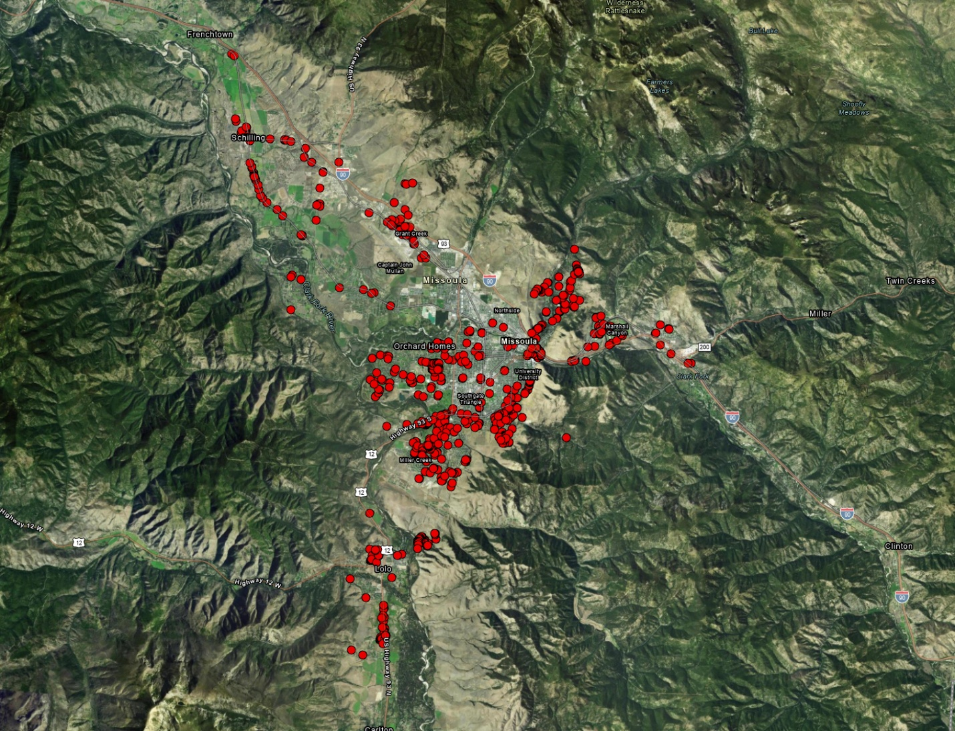

Figure : Russian Olive in Missoula

The dataset categorizes Russian Olive observations into four settings, which provide insight into how the species is established in the area:

* **Ornamental (Blue)**: Planted intentionally by individuals (e.g., for landscaping).
* **Escaped (Red):** Established from seeds dispersed from other plants.
* **Windbreak (Green):** Planted as part of a windbreak
* **Other:** Includes cases where the setting is unknown or does not fit into the above categories.

Figure : Setting of Russian Olive in Missoula

Last, I want to know what growth stage the observed plant is at. Like the woody setting there are several different stages that are observed, including:

* **Immature (Red):** Not yet fully grown.
* **Mature (Blue):** Fully grown and likely reproducing.
* **Seedling (Green):** Recently sprouted.
* **Senescent (Yellow):** Older plants in decline.
* A satellite view of a mountain range

  AI-generated content may be incorrect.**Other:** Includes cases where the growth stage is unknown or not specified.

Figure : Growth Stage of Russian Olive in Missoula

One limitation of these maps is several observations categorized as "Other" or "NA." This is primarily due to the state dataset, which does not consistently record setting or growth stage information. Despite this limitation, the available data still provides valuable insights into the distribution and characteristics of Russian Olive in Missoula County.

## Random Forest Results

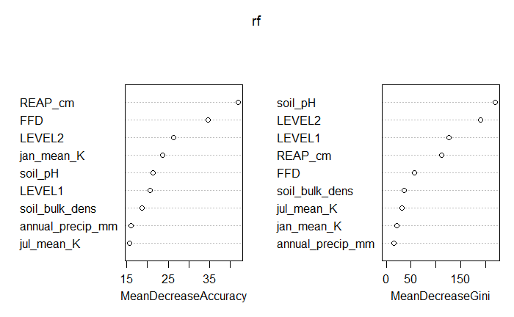The Random Forest model identified several environmental variables as having the most significant impact on the likelihood of Russian Olive presence in each location. These variables, ranked by their importance, are listed in Table 1. Key factors include REAP, Frost Free Days, LEVEL2 land cover, and soil_pH which align with known ecological preferences of Russian Olive.

Figure : Variable Importance

Digging into these results a little further, I want to see what factors within Land Cover contributed the most to the model performance. Figure 6 contains all the variables, some of the significant ones include Conifer Forest, Deciduous Grassland and Shrubland, and Montane Grassland and Shrubland.

Using these results, I generated a habitat suitability map for Missoula County (see Figure 7). This map visualizes the predicted probability of Russian Olive presence, ranging from 0 (low suitability) to 1 (high suitability). Areas with high predicted probabilities are highlighted, providing a clear guide for targeted management and A map of a mountain range
remediation efforts.

The habitat suitability map reveals several key patterns:

1. **Riparian Zones:** Russian Olive is most likely to be found near rivers and streams, consistent with its known preference for moist, disturbed habitats.
2. **Urban and Suburban Areas:** The model also identified high suitability in developed areas, likely due to ornamental plantings and human-mediated dispersal.
3. **Remote Areas:** Some high-suitability areas were located far from water sources, suggesting that Russian Olive could potentially spread outside of known areas.

Figure : Habitat Suitability Map of Missoula, Red having the highest probability of Russian Olive

The model achieved an accuracy of approximately 98%, as indicated by an out-of-bag (OOB) error rate of about 2%. The OOB error is an unbiased estimate of the model's generalization performance, calculated using samples not included in the training of each tree. To further evaluate the performance, I produced a ROC curve (see Figure 8), which displays the model’s ability to distinguish between presence and absence points. The AUC (Area Under the Curve) value of .989 indicates it has strong performance of predicting the presence of Russian Olive given the environmental variables.

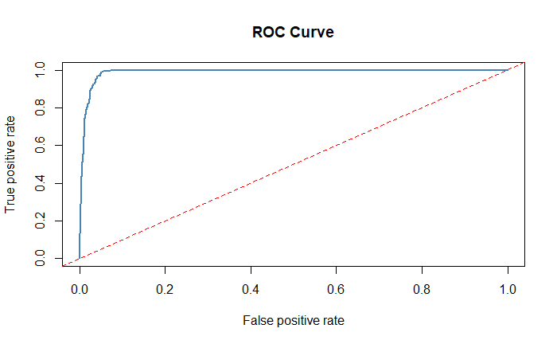Despite these results, the model has several limitations. First, its accuracy is heavily dependent on the quality and preprocessing of the input data. For example, the model relies heavily on the assumption that the points marked as having Russian olive are reliable. Another limitation is the amount of data, overall, there are around 800+ presence points for Russian Olive, this is a decent amount but still a small sample size overall.

Figure : ROC Curve

Second, the model assumes that the environmental conditions driving Russian Olive distribution remain consistent over time, which may not account for future changes due to climate change or human activity. Finally, the model’s predictions are limited to the spatial and temporal scope of the data, meaning it may not fully capture rare or emerging patterns of invasion.

# Recommendations

Based on the model findings, I have identified specific areas of interest where immediate action is recommended to mitigate the spread of Russian Olive. These areas, highlighted in Figure 9, represent regions with the highest habitat suitability scores and concentration of known infestations.

Figure : Areas of Interest

While I am not an expert in invasive species removal, my personal experience—gained through assisting my father, a longtime city arborist—has taught me the importance of careful planning and consideration of ecological impacts. Russian Olive, despite being invasive, can provide habitat for native birds and insects. This complicates efforts to remove it without also considering the potential consequences for local wildlife.

To address this, I recommend the following strategies in the areas of risk:

**Targeted Removal and Treatment**

In areas with high Russian Olive density, I recommend a combination of removal and treatment. As suggested by Lesica and Miles (2001), mature Russian Olive trees can be effectively controlled through herbicide treatment every 10 years, while younger trees may require treatment every 30 years. This approach balances population control with minimal disruption to native wildlife.

**Replacement with Native Species**

To restore ecological balance, I recommend replacing removed Russian Olive trees with native species, particularly **Cottonwood**. Cottonwoods are well-suited to riparian habitats and are the native species most frequently displaced by Russian Olive. Replanting with Cottonwood or other native species will help reestablish native ecosystems and reduce the likelihood of reinvasion.

**Monitoring and Adaptive Management**

Finally, I recommend establishing a **long-term monitoring program** to track the effectiveness of removal and replanting efforts. This program should include regular surveys of treated areas to assess Russian Olive regrowth, the health of replanted native species, and the overall recovery of the ecosystem. Adaptive management strategies can then be implemented based on monitoring results to ensure continued success.

# Conclusion

This project significantly enhances our understanding of Russian Olive distribution and habitat suitability in Missoula County. By providing the Missoula County Ecology Extension and the Missoula County Weed Board with actionable insights, this report supports targeted management efforts to control the spread of Russian Olive. While the task of managing and eradicating invasive species in the county is substantial, I hope this project serves as a valuable resource and paves the way for future efforts to address new invasive species in the region.

A key goal of this project was to create a flexible framework that can be adapted for other species of interest without requiring a complete rebuild of the program. This approach mirrors systems like the Montana Natural Heritage Program’s, which allows users to input data for different species and generate similar models. Developing such an adaptable tool could greatly benefit invasive species management in Missoula County, saving staff time and resources that could be redirected to other critical tasks.

# Appendices

Table 1: Input Variables and Sources

| **Category** | **Variable** | **Description** | **Source** |
| --- | --- | --- | --- |
| **Land Cover** | Level 2 Classification | Intermediate detail with 27 land cover categories. Provides sufficient detail without complexity. | Montana Spatial Data Infrastructure (MSDI) |
|  | Level 1 Classification | Broad categorizations with 8 land cover classes. | MSDI |
|  | Level 3 Classification | Highly granular, with each 30-meter pixel assigned a unique value. | MSDI |
| **Climate** | Frost-Free Days | Estimated number of days without frost (daily minimum temperature > 32°F). | Montana Climate Office |
|  | Relative Effective Annual Precipitation (REAP) | 30-year precipitation data adjusted for slope and aspect. | Montana Climate Office |
|  | Precipitation | Mean annual precipitation (mm) for the 1991–2020 period. | Montana Climate Office |
|  | Maximum/Minimum Temperature | Mean maximum and minimum temperatures (°C) in July and January, respectively. | Montana Climate Office |
| **Soil** | Soil pH | pH of the topsoil layer (0–5 cm depth). | MSDI |
|  | Bulk Density | Mass of the topsoil layer (0–5 cm depth). | MSDI |

Table 2: Land Cover LEVEL2 Variable Importance

| **LEVEL2**  <fctr> | **yhat**  <dbl> |
| --- | --- |
|  | 0.2490742 |
| Agriculture | 0.2111528 |
| Alpine Grassland and Shrubland | 0.3297592 |
| Alpine Sparse and Barren | 4.3514373 |
| Conifer-dominated forest and woodland (mesic-wet) | 5.6327871 |
| Conifer-dominated forest and woodland (xeric-mesic) | 7.8826267 |
| Deciduous Shrubland | 7.3994282 |
| Developed | -4.3618489 |
| Floodplain and Riparian | 4.9507483 |
| Harvested Forest | 3.2401241 |
| Mining and Resource Extraction | -4.3628590 |
| Mixed deciduous/coniferous forest and woodland | 4.5046989 |
| Montane Grassland | 7.3229765 |
| na | 4.3501834 |
| Open Water | 0.6651857 |
| Recently burned | 5.9953899 |
| Sagebrush Steppe | 0.3256712 |
| Wet meadow | 4.0268099 |

# References

Barbet-Massin, M., Jiguet, F., Albert, C.H. and Thuiller, W. (2012), *Selecting pseudo-absences for species distribution models: how, where and how many?* Methods in Ecology and Evolution, 3: 327-338. <https://doi.org/10.1111/j.2041-210X.2011.00172.x>

Lesica, P. and S. Miles. 2001. *Natural history and invasion of Russian olive along eastern Montana rivers*. Western North American Naturalist 61(1):1-10.

Lesica, P., M.T. Lavin, and P.F. Stickney. 2012. *Manual of Montana Vascular Plants*. Fort Worth, TX: BRIT Press. viii + 771 p.

Montana Natural Heritage Program. 2023. *Elaeagnus angustifolia (Russian Olive) predicted suitable habitat model* created on March 14, 2023. Montana Natural Heritage Program, Helena, MT. 17 pp.

Program, M. N. H. (n.d.). *Russian olive*. Montana Field Guide. Retrieved March 23, 2025, from https://fieldguide.mt.gov/speciesDetail.aspx?elcode=PDELG01010

Tobalske, C., Vance, L. K., United States Environmental Protection Agency, & Montana Natural Heritage Program. (2017). *Predicting the distribution of Russian olive stands in eastern Montana valley bottoms using NAIP imagery*. Montana Natural Heritage Program.

1.
2. Lesica, P. and S. Miles. 2001. *Natural history and invasion of Russian olive along eastern Montana rivers*. Western North American Naturalist 61(1):1-10.
3. Lesica, P. and S. Miles. 2001. *Natural history and invasion of Russian olive along eastern Montana rivers*. Western North American Naturalist 61(1):1-10.
4. Barbet-Massin, M., Jiguet, F., Albert, C.H. and Thuiller, W. (2012), *Selecting pseudo-absences for species distribution models: how, where and how many?* Methods in Ecology and Evolution, 3: 327-338. <https://doi.org/10.1111/j.2041-210X.2011.00172.x>